Assignment 4: SQL Implementation

Please use the Relational Data Model on the last page to implement a database.

1. Transform the relational model (attached) to SQL DDL, and implement in MySQL database, and generate a final screenshot of database and all the tables created under the schema;

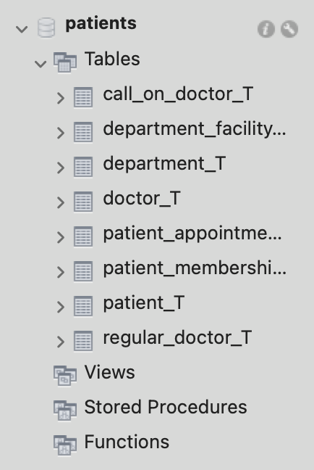

2. Populate the tables with at least 5 rows per table. Note that rows in associative entity relations may not be 5 (could be more or fewer) since they are subject to the relationships between regular entity relations.

Department table

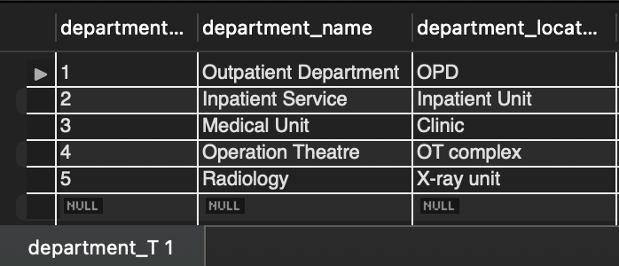

Doctor table

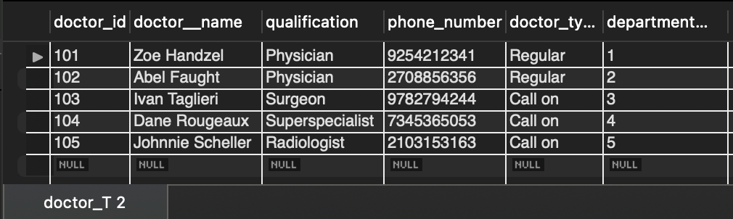

Call on doctor table

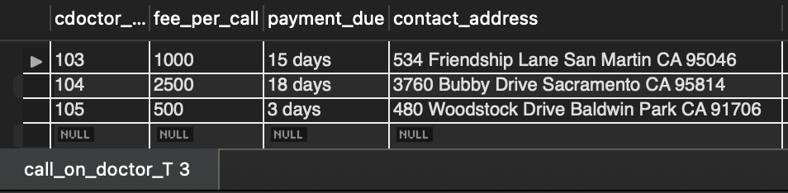

Regular doctor table

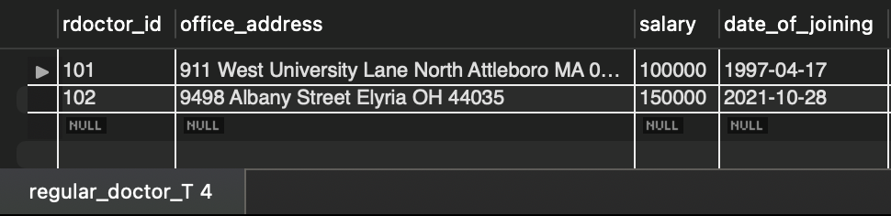

Patient Table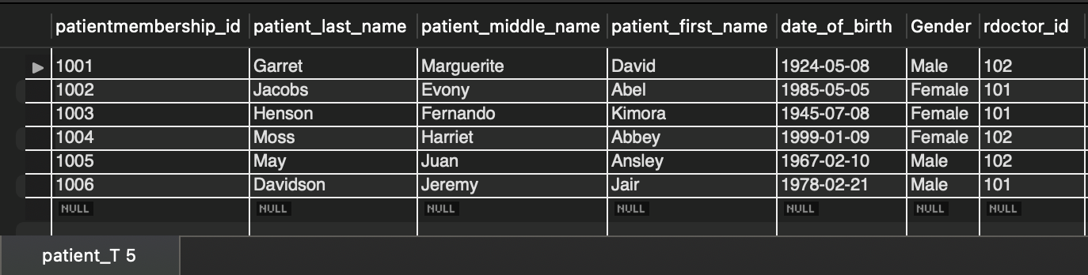

Patient membership type table

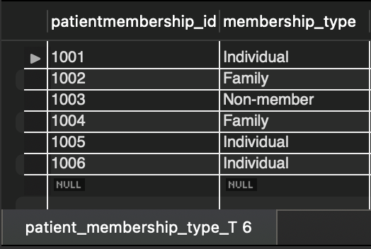

Patient appointment table 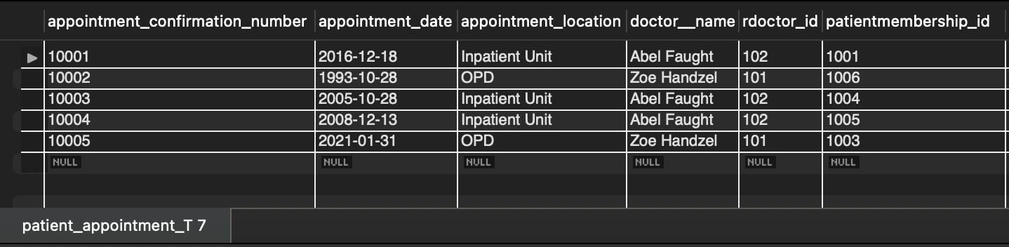

Department facility table

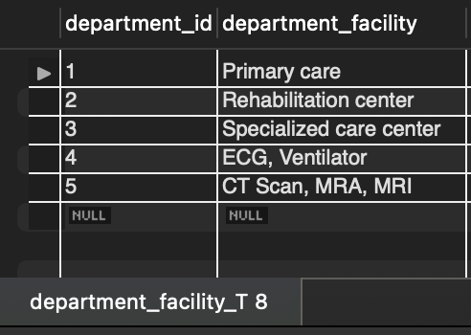

3. List patient information for patients who have made appointment on an appointment date and with a particular doctor name (You decide on the values of any date and doctor name based on your inserted values). Use Equi-join. 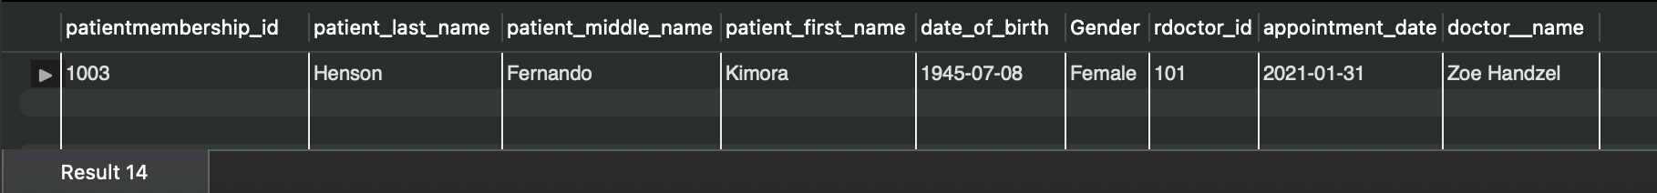

4. List regular doctor information who’s name starts with a letter ‘J’ and who work at a particular department name (You decide on the values of department name based on your inserted values). Use Inner Join.

Returns 0 rows as there is no regular doctor whose name starts with ‘J’. To show the working of the command, below is the screenshot of doctor information whose name starts with ‘A’ along with their department name.

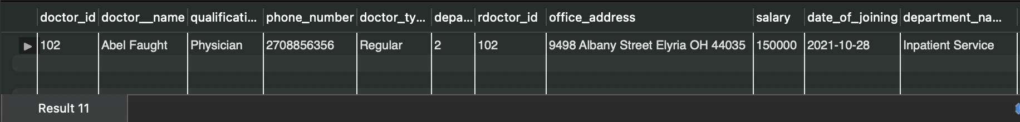

5. Do a LEFT JOIN on DEPARTMENT and DEPARTMENT_FACILITY tables.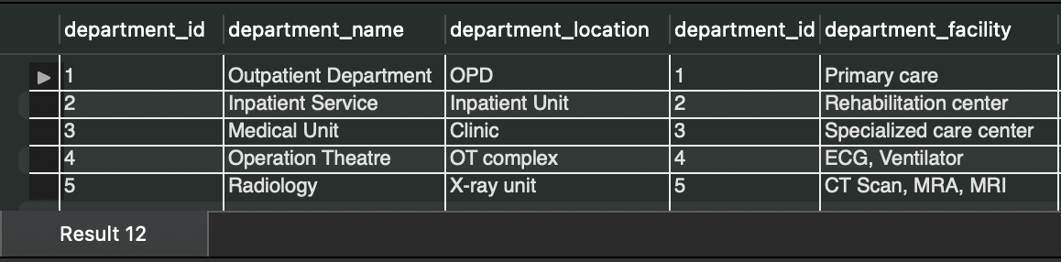

6. List doctorid from CALL_ON_DOCTOR and REGULAR_DOCTOR tables using UNION.

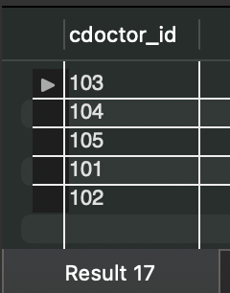

7. Create a dynamic VIEW for patient information whose caring doctor’s salary is over $100,000.

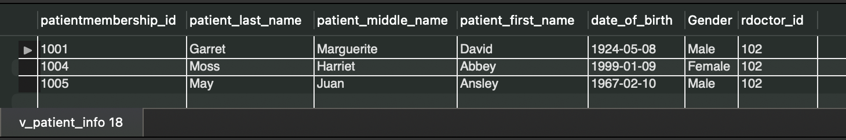

Submit both the .sql file and your word document file containing the working SQL DDL and DML queries output screenshots to Blackboard. Do note down any assumptions that you make if any such information is missing in the homework instructions.

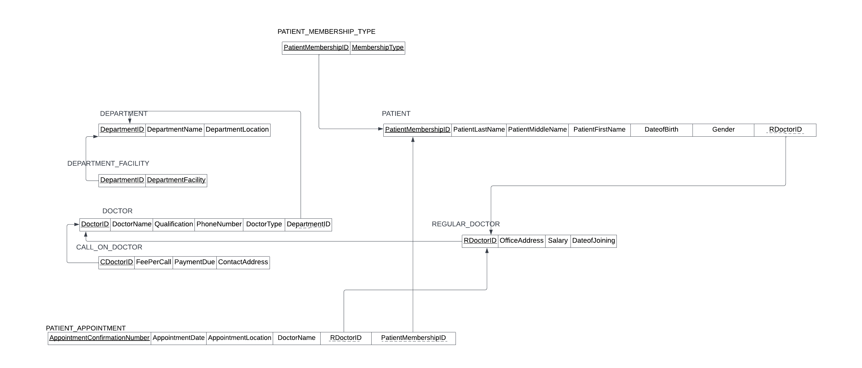

DEPARTMENT

|  |  |  |  |  |  |
| --- | --- | --- | --- | --- | --- |
| Attribute | Data Type | Size | AUTO | Null | Constraint |
| DepartmentID | Int | 11 | Yes | No | Primary |
| DepartmentName | varchar | 25 | No | No |  |
| DepartmentLocation | Varchar | 25 | No | Yes |  |

DOCTOR

|  |  |  |  |  |  |
| --- | --- | --- | --- | --- | --- |
| Attribute | Data Type | Size | AUTO | Null | Constraint |
| DoctorID | Int | 11 | Yes | No | Primary |
| DoctorName | varchar | 25 | No | No |  |
| Qualification | Varchar | 25 | No | Yes |  |
| PhoneNumber | varchar | 25 | No | Yes |  |
| DoctorType | Varchar | 10 | No | No |  |
| DepartmentID | Int | 11 | No | No | Foreign |

CALL ON DOCTOR

|  |  |  |  |  |  |
| --- | --- | --- | --- | --- | --- |
| Attribute | Data Type | Size | AUTO | Null | Constraint |
| CDoctorID | Int | 11 | Yes | No | Primary and foreign |
| FeePerCall | double |  | No | No |  |
| PaymentDue | varchar | 20 | No | No |  |
| ContactAddress | Varchar | 50 | No | Yes |  |

REGULAR DOCTOR

|  |  |  |  |  |  |
| --- | --- | --- | --- | --- | --- |
| Attribute | Data Type | Size | AUTO | Null | Constraint |
| RDoctorID | Int | 11 | Yes | No | Primary and foreign |
| OfficeAddress | Varchar | 50 | No | Yes |  |
| Salary | Double |  | No | Yes |  |
| DateofJoining | Date |  | No | Yes |  |

PATIENT

|  |  |  |  |  |  |
| --- | --- | --- | --- | --- | --- |
| Attribute | Data Type | Size | AUTO | Null | Constraint |
| PatientMembershipID | Int | 11 | Yes | No | Primary |
| PatientLastName | varchar | 25 | No | No |  |
| PatientMiddleName | Varchar | 25 | No | Yes |  |
| PatientFirstName | Varchar | 25 | No | No |  |
| DateofBirth | Date |  | No | Yes |  |
| Gender | Varchar | 6 | No | Yes |  |
| RDoctorID | Int | 11 | No | No | Foreign |

PATIENT MEMBERSHIP TYPE

|  |  |  |  |  |  |
| --- | --- | --- | --- | --- | --- |
| Attribute | Data Type | Size | AUTO | Null | Constraint |
| PatientMembershipID | Int | 11 | No | No | Part of Primary, foreign |
| MembershipType | varchar | 30 | No | No | Part of primary |

PATIENT APPOINTMENT

|  |  |  |  |  |  |
| --- | --- | --- | --- | --- | --- |
| Attribute | Data Type | Size | AUTO | Null | Constraint |
| AppointmentConfirmationNumber | Int | 11 | Yes | No | Primary |
| AppointmentDate | Date |  | No | No |  |
| AppointmentLocation | Varchar | 50 | No | No |  |
| DoctorName | Varchar | 25 | No | No |  |
| RDoctorID | Int | 11 | No | No | Foreign |
| PatientMembershipID | Int | 11 | No | No | Foreign |

DEPARTMENT FACILITY

|  |  |  |  |  |  |
| --- | --- | --- | --- | --- | --- |
| Attribute | Data Type | Size | AUTO | Null | Constraint |
| DepartmentID | Int | 11 | No | No | Part of Primary, foreign |
| DepartmentFacility | varchar | 30 | No | No | Part of primary |